Mongo DB:

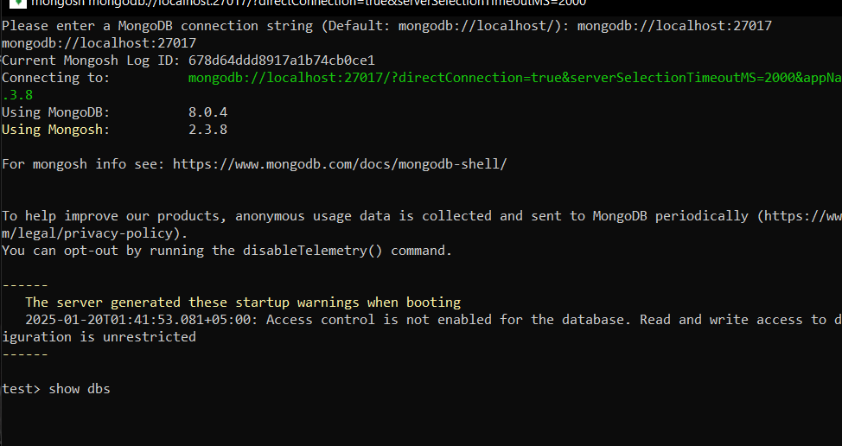

Mongo Db has collections and collections has fields,

Table -> Collections

Rows -> Documents

Columns -> Fields

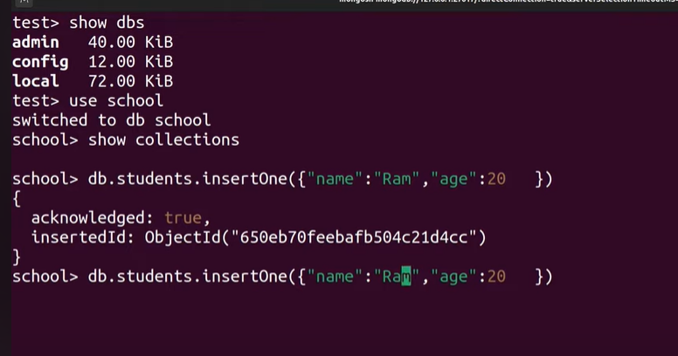

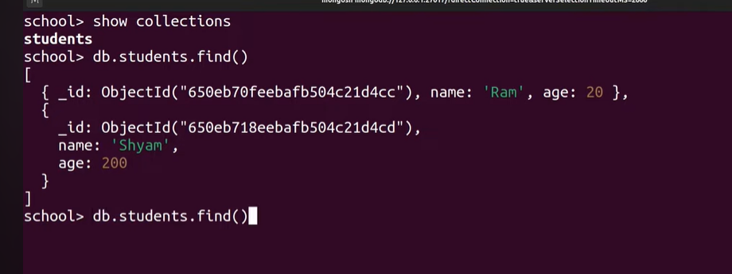

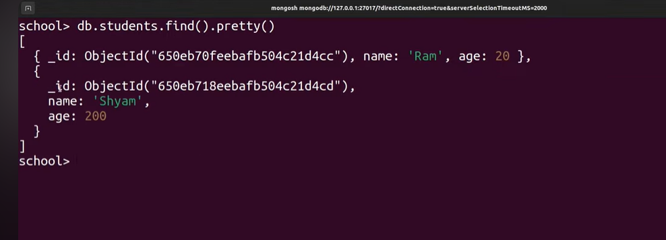

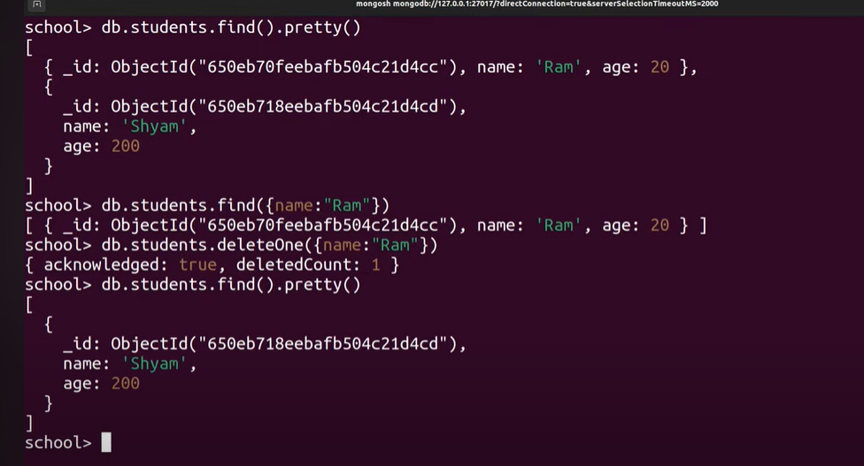

**ORM:**

Object relational mapping. ORM is a technique used to map java objects to java tables.



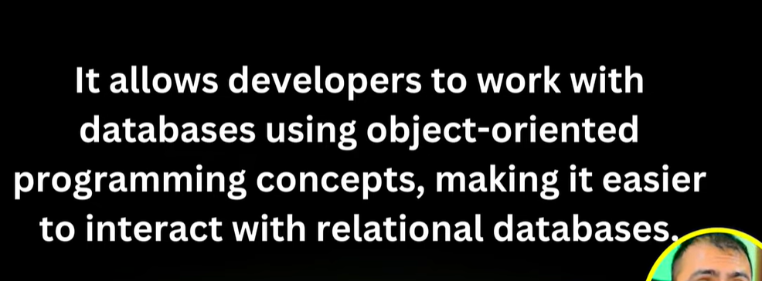

**JPA:**

Java Persistence API







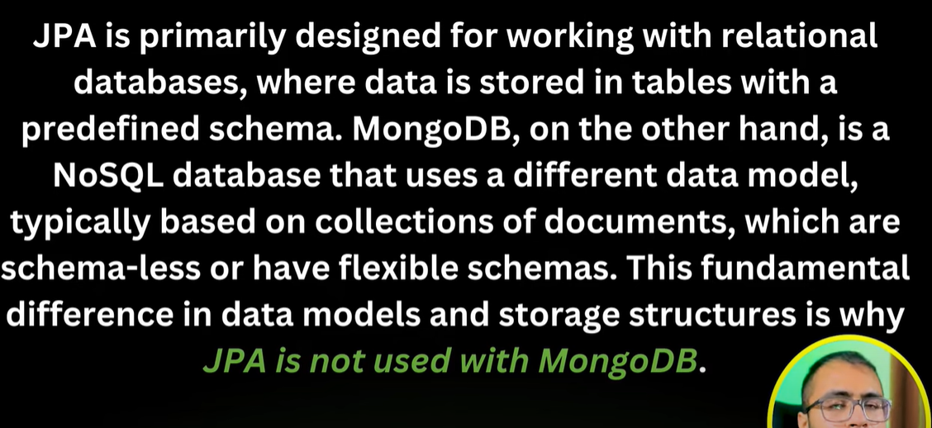



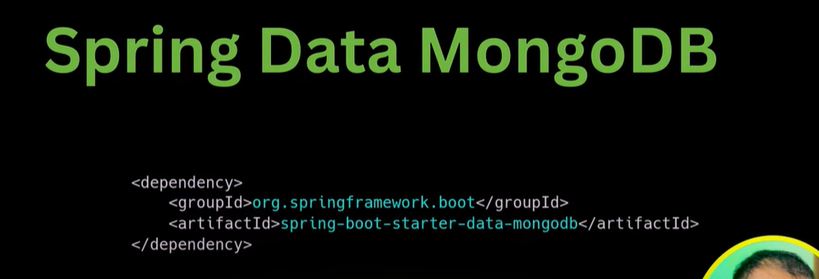

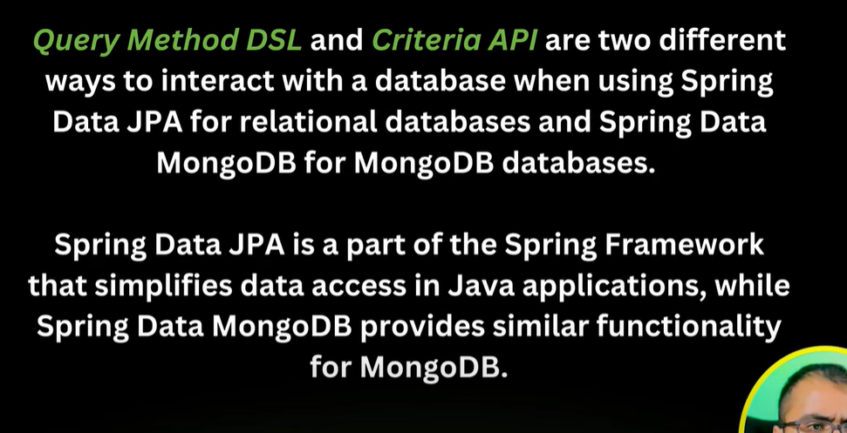

Application.properties

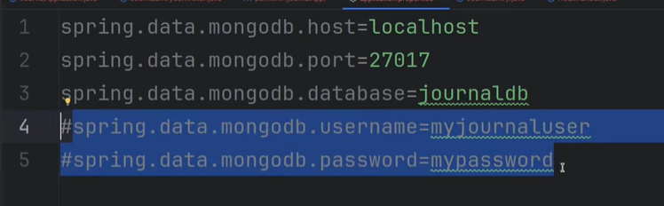

Controllers’ user Services. (interaction with DB methods in services)

Reload the project

<https://stackoverflow.com/questions/63523595/intellij-idea-cannot-resolve-spring-boot-starter-data-mongodb>

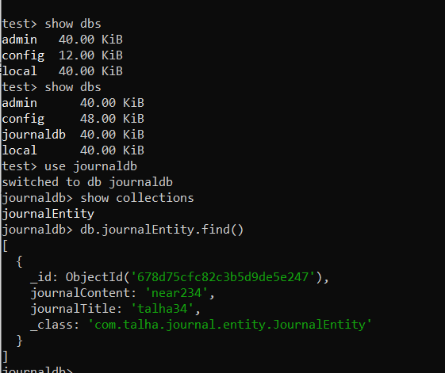

Agr id dugy tu wo lelega like 2 otherwise mongodb khud ka krlyga id

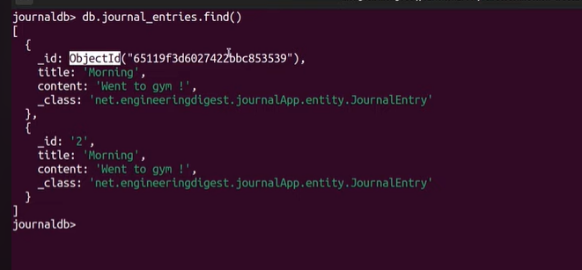

Make sure to write collection name correct in entity class